“Stock price trend web-app”

Submitted in partial fulfillment of the requirements of the degree

**BACHELOR OF ENGINEERING IN COMPUTER ENGINEERING**

By

**Vipul Bhavar Roll No:08**

**Vishakha Borkar Roll No:11**

**Pranav Dave Roll No:18**

Supervisor

**Prof.**

# CERTIFICATE

This is to certify that the Mini Project entitled **“Stock price trend web-app”** is a bonafide work of **Vipul Bhavar (Roll No:08), Vishakha Borkar (Roll No:11), Pranav Dave (Roll No:18) ,** submitted to the University of Mumbai in partial fulfillment of the requirement for the award of the degree of **“Bachelor of Engineering”** in **“Computer Engineering” .**

### **(Prof. SHWETA SHARMA )**

Supervisor

### **(Prof. Dr. SUVARNA PANSAMBAL) (Prof. SHRIKANT KALLURKAR)**

Head of Department Principal

# Mini Project Approval

This Mini Project entitled **“Stock price trend web-app”** by **Vipul Bhavar (Roll No:08), Vishakha Borkar (Roll No:11), Pranav Dave (Roll No:18)** is approved for the degree of **Bachelor of Engineering** in **Computer Engineering.**

## Examiners

**1………………………………………**

(Internal Examiner Name & Sign)

## 2…………………………………………

(External Examiner name & Sign)

Date:

Place:

# Contents

## Abstract

* 1. **Introduction**
  2. Introduction
  3. Motivation
  4. Problem Statement & Objectives
  5. Organization of the Report

## Literature Survey

* + 1. Survey of Existing System
    2. Limitation Existing system or research gap
    3. Mini Project Contribution

## Proposed System (eg New Approach of Data Summarization )

* + 1. Introduction
    2. Architecture/ Framework
    3. Algorithm and Process Design
    4. Details of Hardware & Software
  1. Experiment and Results
  2. Conclusion and Future work.
* **References**

**ABSTRACT:**

In this project we attempt to implement machine learning approach to predict stock prices. Machine learning is effectively implemented in forecasting stock prices. The objective is to predict the stock prices in order to make more informed and accurate investment decisions. We propose a stock price prediction system that integrates mathematical functions, machine learning, and other external factors for the purpose of achieving better stock prediction accuracy and issuing profitable trades. There are two types of stocks. You may know of intraday trading by the commonly used term "day trading." Interday traders hold securities positions from at least one day to the next and often for several days to weeks or months. Time-forecasting are very powerful in sequence prediction problems because they’re able to store past information. This is important in our case because the previous price of a stock is crucial in predicting its future price. While predicting the actual price of a stock is an uphill climb, we can build a model that will predict whether the price will go up or down.

1. **INTRODUCTION:**
   1. **INTRODUCTION TO: STOCK MARKET**

The financial market is a dynamic and composite system where people can buy and sell currencies, stocks, equities and derivatives over virtual platforms supported by brokers. The stock market allows investors to own shares of public companies through trading either by exchange or over the counter markets. This market has given investors the chance of gaining money and having a prosperous life through investing small initial amounts of money, low risk compared to the risk of opening new business or the need of high salary career. Stock markets are affected by many factors causing the uncertainty and high volatility in the market. Although humans can take orders and submit them to the market, automated trading systems (ATS) that are operated by the implementation of computer programs can perform better and with higher momentum in submitting orders than any human

* 1. **MOTIVATION:**

Businesses primarily run over customer’s satisfaction, customer reviews about their products. Shifts in sentiment on social media have been shown to correlate with shifts in stock markets. Identifying customer grievances thereby resolving them leads to customer satisfaction as well as trustworthiness of an organization. Hence there is a necessity of an un biased automated system to classify customer reviews regarding any problem. In today’s environment where we’re justifiably suffering from data overload (although this does not mean better or deeper insights), companies might have mountains of customer feedback collected; but for mere humans, it’s still impossible to analyse it manually without any sort of error or bias. Oftentimes, companies with the best intentions find themselves in an insights vacuum. You know you need insights to inform your decision making and you know that you’re lacking them, but don’t know how best to get them. Sentiment analysis provides some answers into what the most important issues are, from the perspective of customers, at least. Because sentiment analysis can be automated, decisions can be made based on a significant amount of data rather than plain intuition.

* 1. **PROBLEM STATEMENT AND OBJECTIVE:**

Time Series forecasting & modelling plays an important role in data analysis. Time series analysis is a specialized branch of statistics used extensively in fields such as Econometrics & Operation Research. Time Series is being widely used in analytics & data science. Stock prices are volatile in nature and price depends on various factors. The main aim of this project is to predict stock prices using Long short term memory (LSTM).

1. **LITERATURE SURVEY:**
   1. **SURVEY OF EXISTING SYSTEM.**

From the research paper “Machine Learning in Stock Price Trend Forecasting” written by Y. Dai and Y. Zhang in Stanford University, they used features like PE ratio, PX volume, PX EBITDA, 10-day volatility, 50-day moving average, etc. to predict the next-day stock price and a long-term stock price [2]. The machine learning algorithms used in the research are Logistic Regression, Gaussian Discriminant Analysis, Quadratic Discriminant Analysis, and SVM. The accuracy ratio is defined as the number of days that the model correctly classified the testing data over the total number of testing days. With the short term model predicting the next day stock price, it has very low accuracy, the Quadratic Discriminant Analysis is the best among all models, it scored a 58.2% accuracy. With the long term model predicting the next n days stock prices, the longer the time frame, the better in the accuracy for SVM. With a time window of 44 days, the SVM model’s accuracy reached 79.3%. Apart from that, it was found that by increasing the number of features, the accuracy increased. When all of the 16 features were used, the accuracy of the model reached 79%, while it fell to 64% when only 8 features were used, and 55% if only 1 feature was used. Our project will also investigate how the timeframe would affect the accuracy of price predictions of different models. As models have to reach a certain threshold to have significance for the users to work as a reference, it is essential for us to optimize our model to figure out what the optimal parameters and model structure are for our stock price prediction purpose. Page 12 of 124 The research paper “Predicting stock and stock price index movement using Trend Deterministic Data Preparation and machine learning techniques” written by J. Patel, S. Shah, P. Thakkar, and K. Kotecha for the “Expert Systems with Applications” international journal demonstrated a way to use trend deterministic data to predict stock price movement [3]. They conducted experiments in using 10 technical indicators’ signals as inputs, then they use prediction models to predict whether the stock will go up or down in the coming 10 days, Technical analysis indicators include SMA, EMA, Momentum, Stochastic SK, Stochastic SK, MACD, RSI, etc. The prediction models they have used include ANN, SVM, Random Forest, and Naive Bayesian models. The model outputs “up” or “down” movement signals. Experiments have shown random forest scored the highest performance with 83.56% accuracy with their inputs. B. Wanjawa and L. Muchemi demonstrated the potential in predicting stock prices using ANN, as shown in the research paper “ANN Model to Predict Stock Prices at Stock Exchange Markets” [4]. They used 70% of the training data to predict the stock prices for the next 60 days. Through optimizations, they were able to predict the actual closing prices within 0.71% mean absolute percentage error (MAPE), with the highest variance -3.2% among all of the 62 days. This demonstrated a high potential for using machine learning to accurately predict stock prices. This is one of the key components in our application where algorithms have to be designed to have high accuracy, such that the platform could be useful for retail investors.

* 1. **LIMITATIONS OF EXISTING SYSTEMS:**
  2. **MINIPROJECT CONTRIBUTION:**

We distributed the entire project in subdivisions, mentioned below. **TEAM MEMBER 1:**

**Vipul Bhavar (Roll number 8):** Compiled CSV for S&P 500, NIFTY 50 and scraped using pandas

**TEAM MEMBER 2:**

**Vishakha Borkar (Roll number 11):** Created front-end, Wrote markdown scripts for Streamlit to parse to web.

**TEAM MEMBER 3:**

**Pranav Dave (Roll number 18)**: Setup environment for sharing project, implemented time-forecasting on listed stocks.

1. **PROPOSED SYSTEM:**
   1. **INTRODUCTION:**

Prophet - a Tool for Time Series Forecasting at Scale The basic building block of the proposed framework for sales forecasting and product portfolio classification is a tool/method for generating high-quality time-series forecasts. Despite the fact that there are numerous tools/methods that can be applied, it was decided to use Facebook’s Prophet tool for this research since it is capable of generating forecasts of a reasonable quality at scale. Prophet, an open-source software released by Facebook’s Core Data Science team, is a procedure developed for forecasting time series data based on an additive model where nonlinear trends are fit with yearly, weekly, and daily seasonality, plus holiday effects. It works best with time series that have strong seasonal effects and several seasons of historical data. Prophet is robust to missing data and shifts in the trend, and typically handles outliers well. According to Taylor and Letham research, Prophet is used in many applications across Facebook for producing reliable forecasts and performs better than any other approach in the majority of cases. In this paper, Facebook’s Prophet tool is used for modelling the dynamics of sales for items in a product portfolio without using additional regressors, with the aim of generating monthly and quarterly sales forecasts. It is worth mentioning that an empirical method for tweaking model parameters is used to incorporate domain knowledge into the proposed framework, but the same parameters are used for the entire product portfolio to avoid overfitting. It is empirically concluded that at least 24 months of historical data is required for reliable estimation of trend and/or seasonal effects

* 1. **ARCHITECTURE/FRAMEWORK:**

**Tech stack used**

* **Programming languages**
  1. **Python**
* **Modules used**
  1. **yfinance**
  2. **numpy**
  3. **pandas**
  4. **cufflinks**
  5. **streamlit**
* **Environment and IDE**
  1. **Conda**
* **Front-end**
  1. **Streamlit and markdown**
* **Back-end**
  1. **Streamlilt server**
  2. **ALGORITHM AND PROCESS DESIGN:**

We have created an web app where you can not only view the exact value of stock price, but also do a technical analysis of the company on the basis of its value over a period of time and also a fundamental analysis wherein given the company business model, sector and its future in the industry.

Prophet based on supervised learning algorithm and is an open-source software that is available in Python and R for forecasting time series data. Prophet is published by Facebooks core Data science team. It depends on a contribution model where non-linear trends can be fit with yearly and weekly seasonality and holidays. We do not need to process our data to make forecasts, the prophet model can work with non-stationary time-series, and it is strong to handle missing data. It captures the shifts in the trend and is good at handle large outliers. In addition to this is also very effective it does not require too much effort to make good prediction. Prophet is optimized for business forecast that are observed on Facebook. For example, time, daily, weekly observations of history within a year, large outliers, trends, Forecasting prices of stocks with Facebook Prophet 10 missing observation, and trend that non-linear. Prophet framework has its own special data frame handle time series and seasonality easily. The data frame needs to be converted to basic columns. The first columns “ds”, stores the time series data and the other column is “y”, and it stores the corresponding values of the time series in the data frame. Prophet model can be set to handle seasonality of the dataset. These options are daily, weekly, and yearly seasonality and provide granularity for the forecast model on the dataset.

**Implementing Time-forecasting using Prophet module**

The mathematical equation behind the Prophet model is defined as:

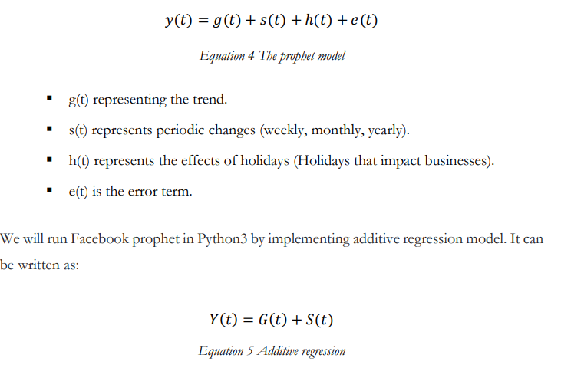

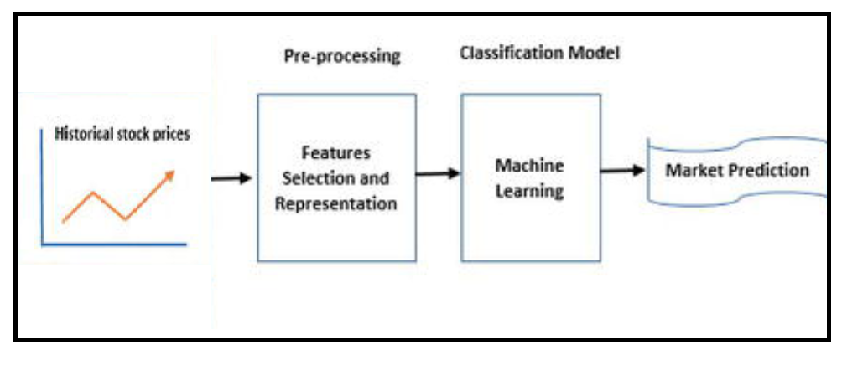

* 1. **DETAILS OF HARDWARE AND SOFTWARE:**

This project is created for web applications so it will work well with any

Operating system given that they have the latest web browser installed

that supports javascript and necessary scripting languages. The user

needn’t to install anything this applications works like a

PWA(progressive web app).

* 1. **EXPERIMENT AND RESULT:**

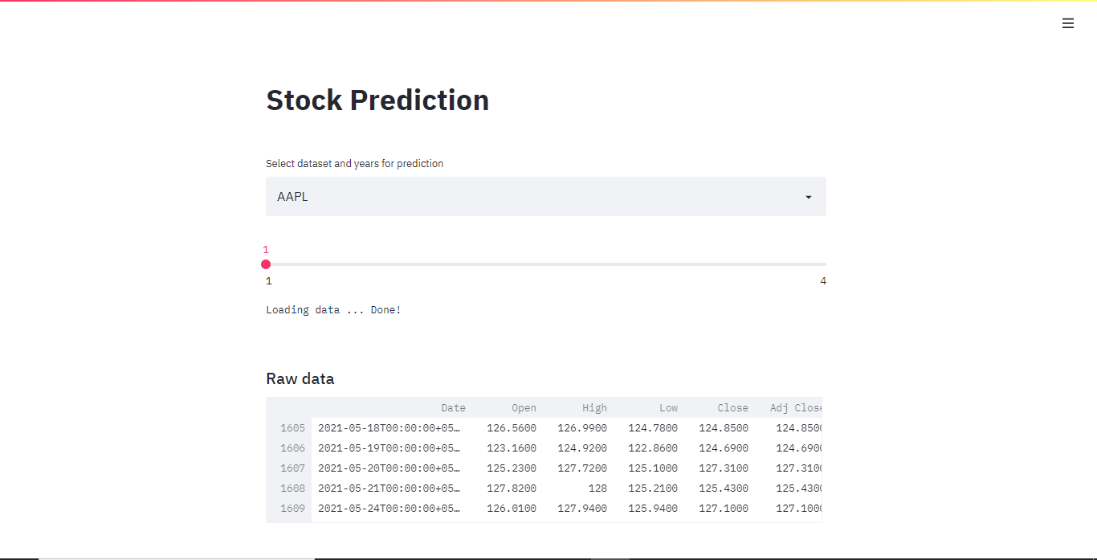

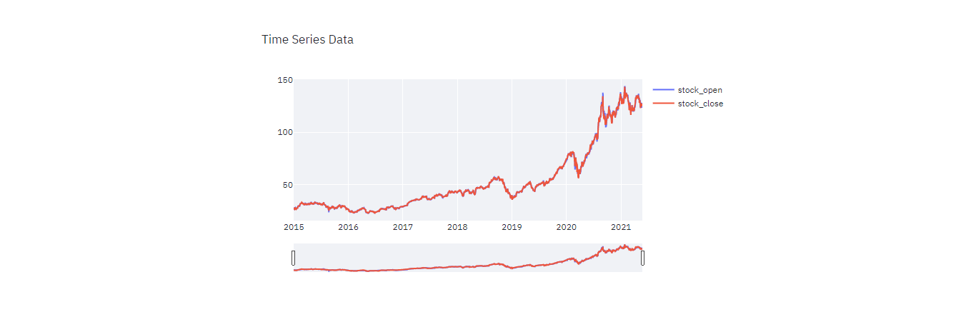

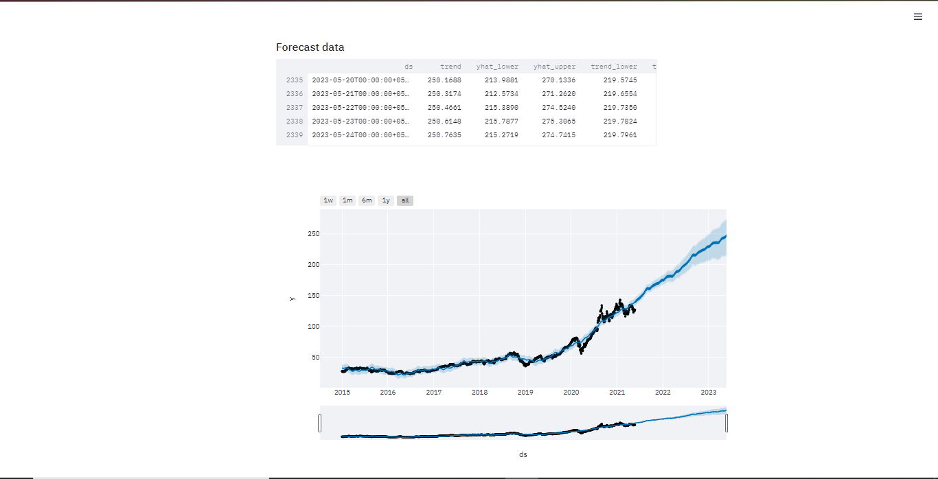

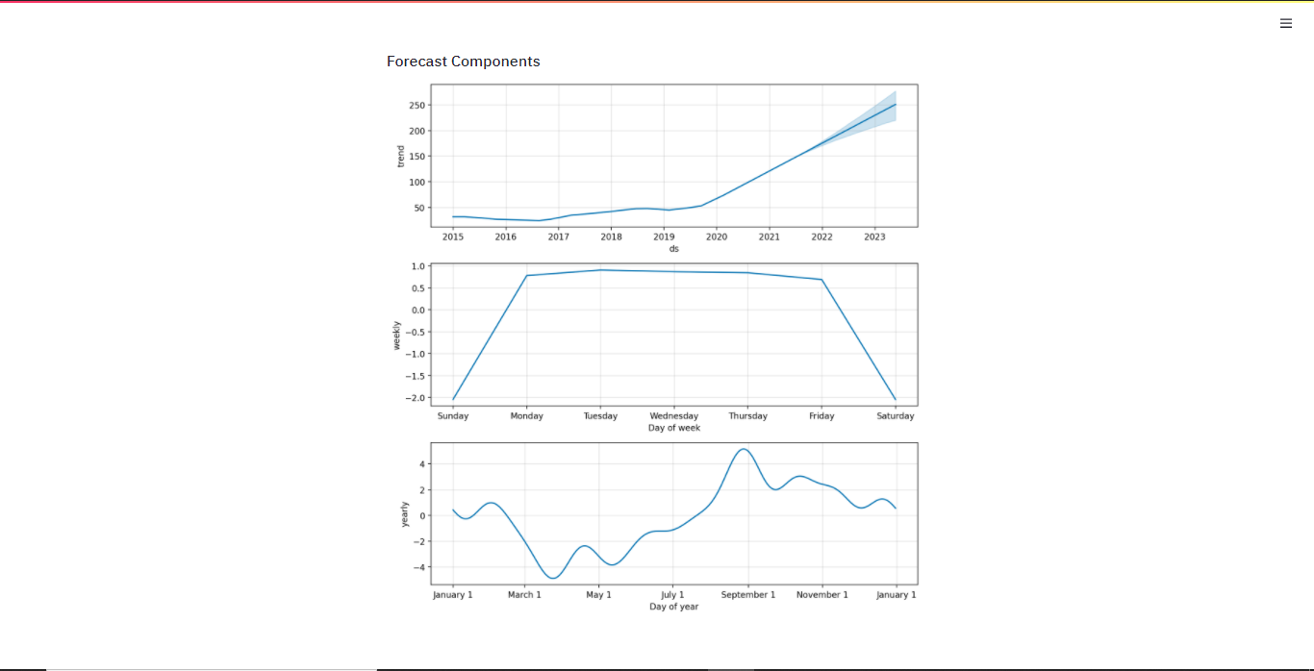

* 1. **CONCLUSION:**

Albeit all the contemplation faced during deciding of which model to choose we created an effective study to decide and stick to one for simplicity, our project team successfully created a prototype stock prediction application for the web platform capable of tracking, recording, and displaying data relevant to stock price which are publicly listed. While the full scope of the initial app design was not realized, all of the core data tracking functionality has been successfully implemented. In conclusion we state that we’ve created an effective solution for improving stock price prediction for trading.

**REFERENCES:**

* <https://www.tensorflow.org/tutorials/structured_data/time_series>
* <https://support.google.com/docs/answer/3093281?hl=en>
* <https://streamlit.io/>
* <https://www.yahoofinanceapi.com/>
* <https://www.analyticsvidhya.com/blog/2018/10/predicting-stock-price-machine-learningnd-deep-learning-techniques-python/>
* <https://ieeexplore.ieee.org/document/8703332>
* <https://ieeexplore.ieee.org/document/9526491>
* <https://facebook.github.io/prophet/docs/quick_start.html>
* <https://github.com/santosjorge/cufflinks>